Phase-4

**Event Management App**

Description:

Build an Angular app where the admin can view and manage employees.

Project Structure

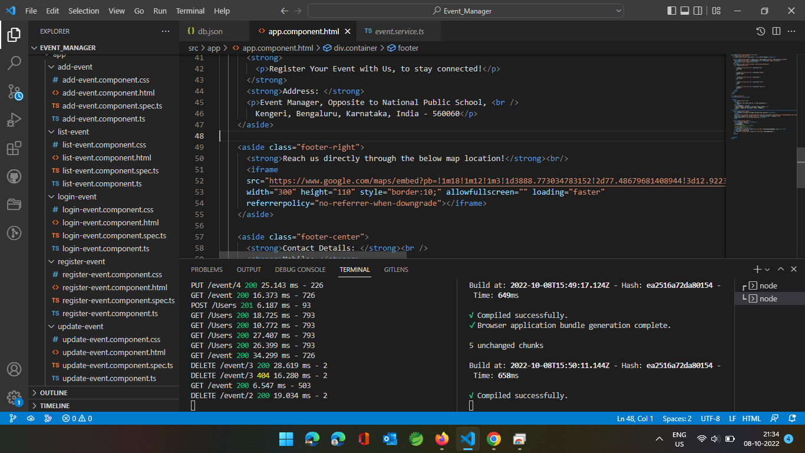

Home Page

**Add New event (Success Alert popped after valid event data entered)**

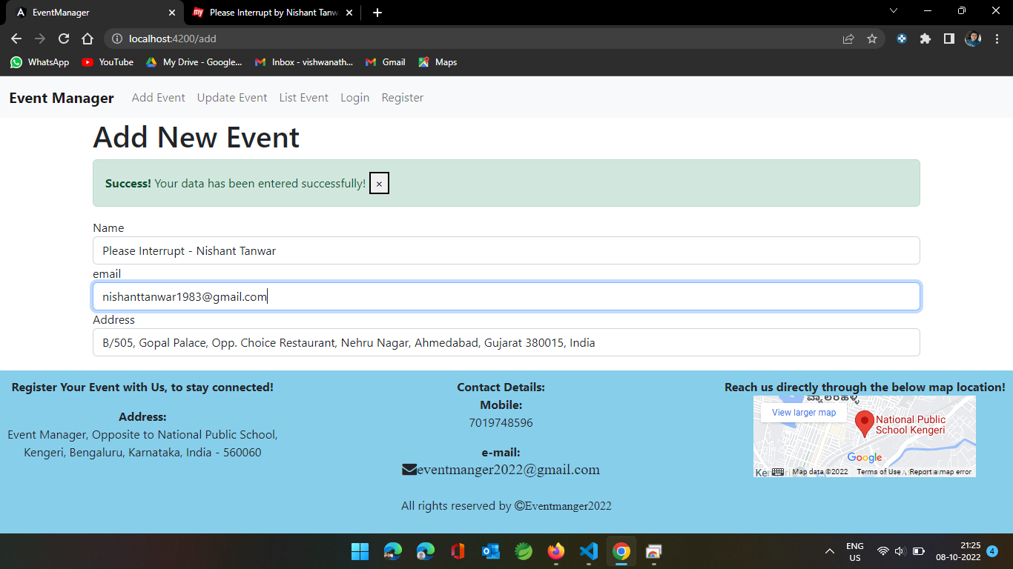

Events list (After the events added from the add page)

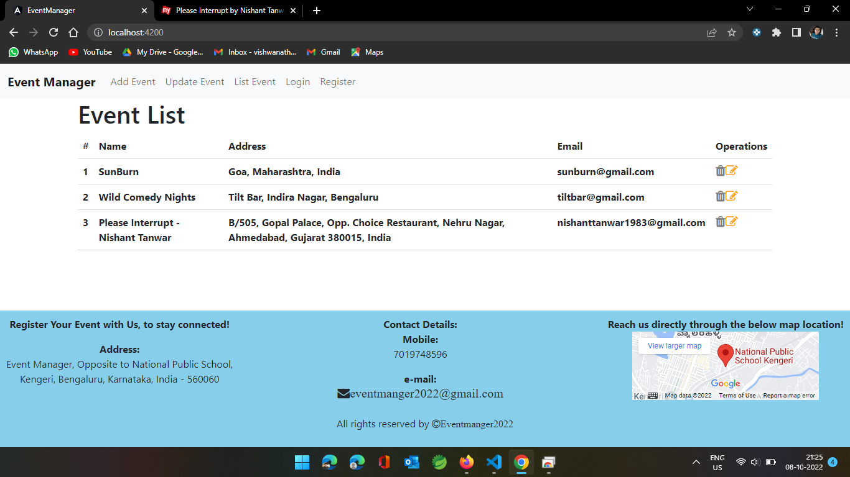

Event List to perform the operations (After adding the events)

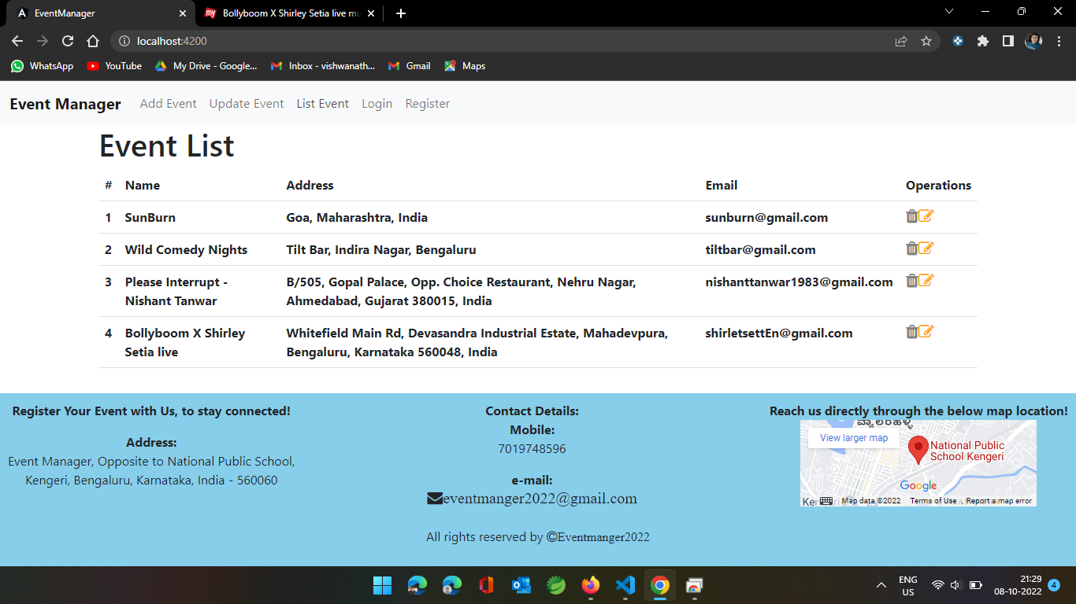

Edit event (By selecting the edit option)

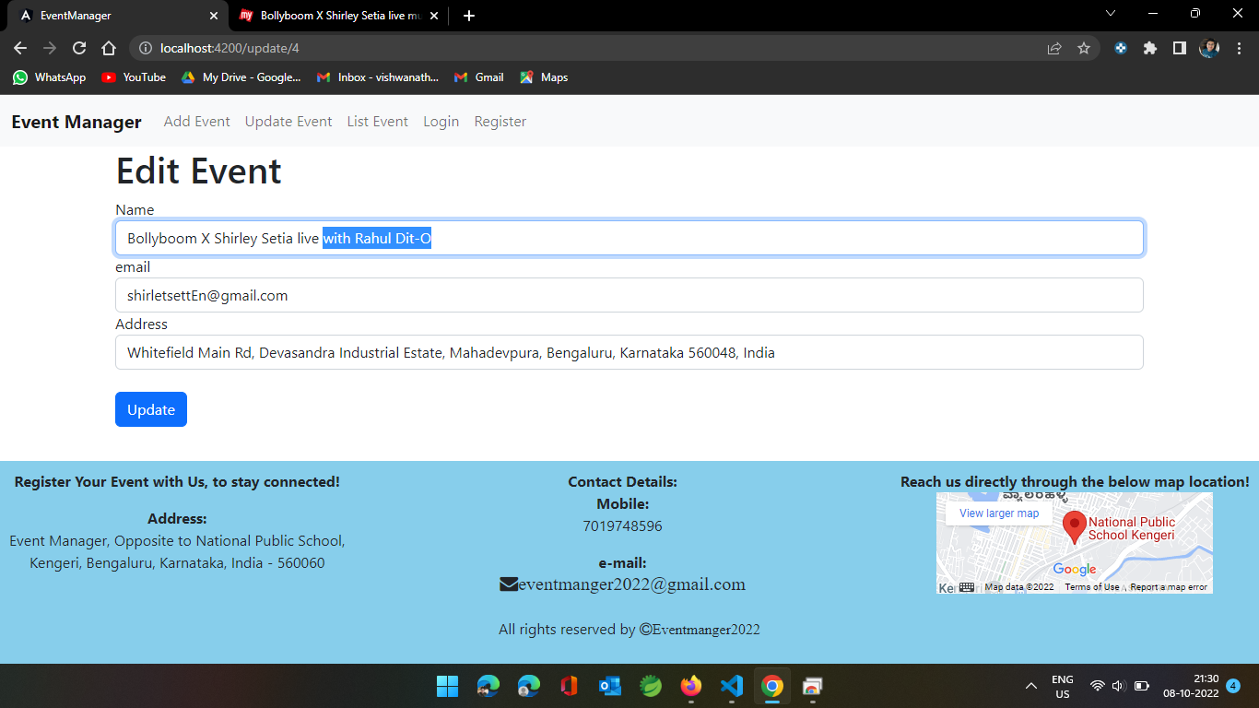

Success alert message for editing the event

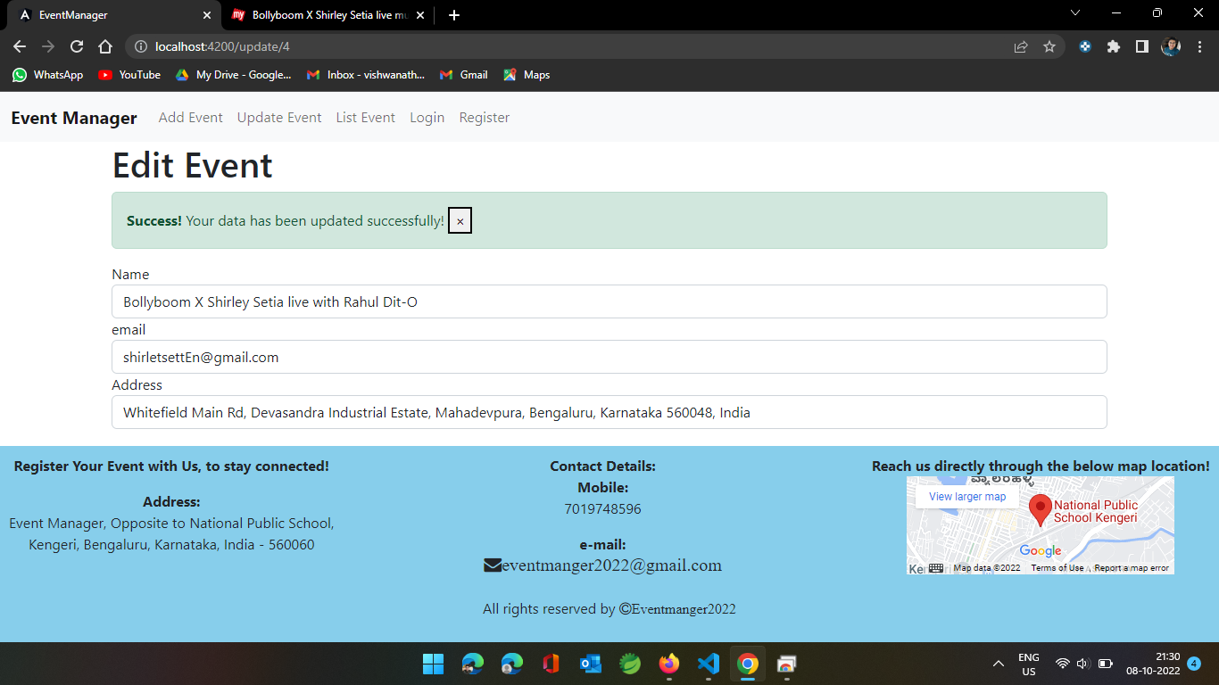

Register Page (Registering a new user, along with success message)

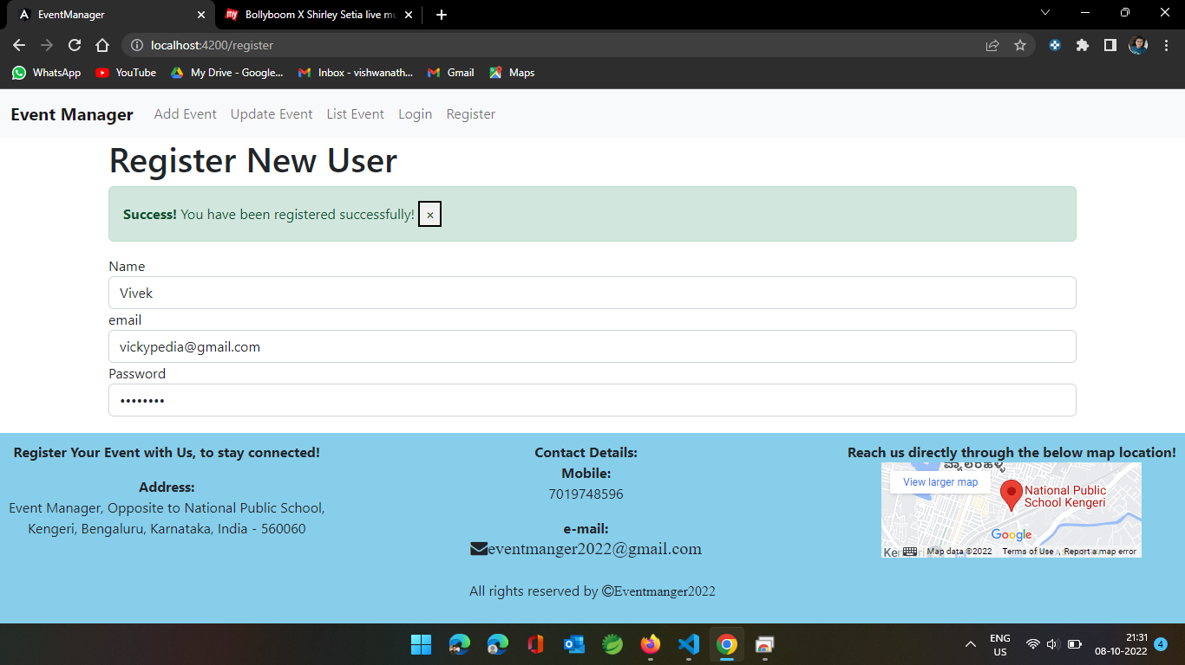

Login Page (Validating the user logs in successfully or no)

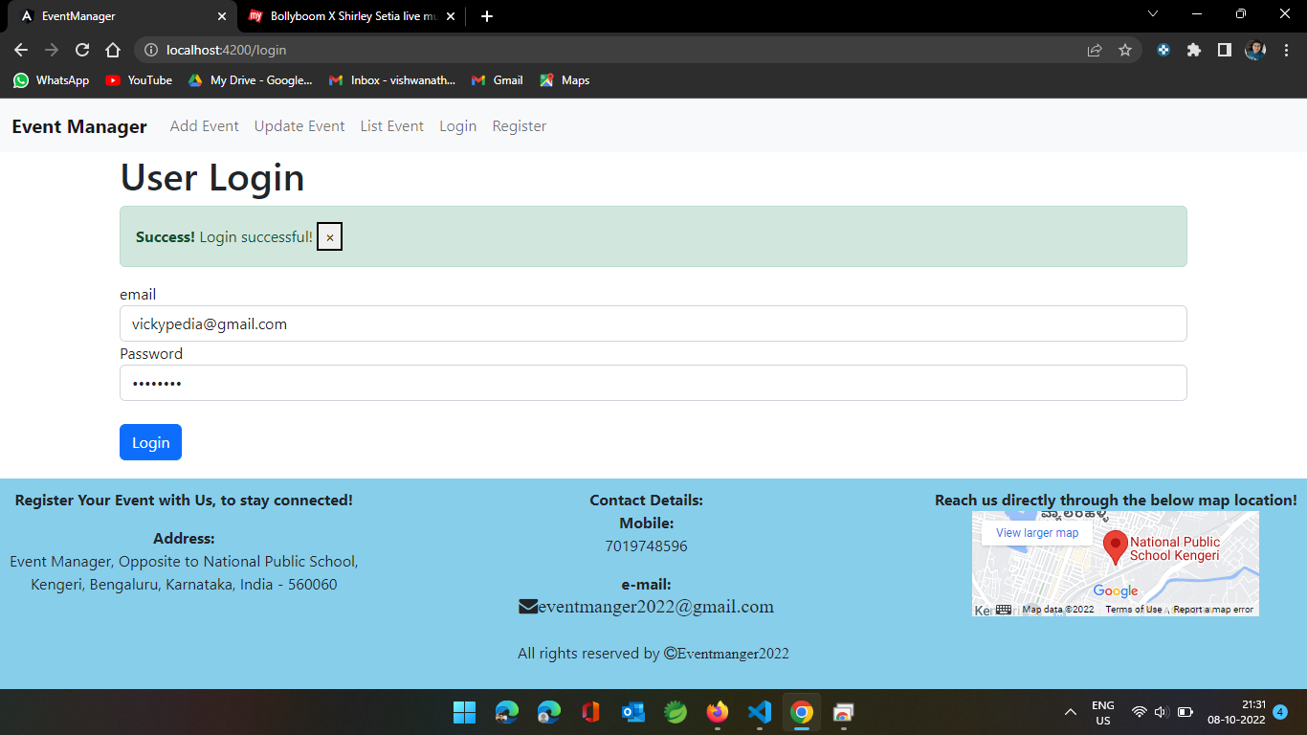

Delete Operation (deleting the event from the list, progress visible in console)

